INTERNSHIP REPORT

A report submitted in partial fulfillment of the requirements for the

BACHELOR OF TECHNOLOGY
in

COMPUTER SCIENCE AND ENGINEERING
by
Pethkar Vishal Vilas
Roll - 67

Under Supervision of Prof.V.V Palmur
(Internship Duration: 2 Months )



DEPARTMENT OF COMPUTER SCIENCE AND ENGINEERING N B NAVALE SINHGAD COLLEGE OF ENGINEERING

Approved by AICTE & Affiliated to Solapur University, Solapur)

Punyashlok Ahilyadevi Holkar University, Solapur – Pune National Highway, Kegaon, Solapur.
2025-26

DEPARTMENT OF COMPUTER SCIENCE AND ENGINEERING N B NAVALE SINHGAD COLLEGE OF ENGINEERING, SOLAPUR

(2025-26)



CERTIFICATE

This is to certify that the “Internship report” submitted by Student Name roll no 67 is work done by her and submitted during A.Y. 2025 – 2026 , in partial fulfillment of the requirements for the award of the degree of BACHELOR OF TECHNOLOGY in COMPUTER SCIENCE AND ENGINEERING, at Ybi Foundation.

Prof. V. V. Palmur Prof. S. A. Dhanawe Prof. H. T. Gurme
Project Guide Internship Coordinator, CSE HOD CSE

KEEP INTERNSHIP CERTIFICATE ON THIS PAGE:



iii

ACKNOWLEDGEMENT

First I would like to thank Company representative name with designation, Address for giving me the opportunity to do an internship within the organization.

I also would like all the people that worked along with me YBI foundation
with their patience and openness they created an enjoyable working environment.

It is indeed with a great sense of pleasure and immense sense of gratitude that I acknowledge the help of these individuals.

I would like to thank my Project Guide Prof. V. V. Palmur, for the valuable guidance and helping me in completion of internship.

I would like to thank Prof S. A. Dhanawe, Department internship coordinator for their support and advices to get and complete internship in above said organization.

I would like to thank my Head of the Department Prof. H. T. Gurme for his motivation and providing resources throughout my internship.

I am extremely grateful to my department staff members and friends who helped me in successful completion of this internship.

Pethkar Vishal Vilas
Roll No - 67

ABSTRACT

This internship report documents a comprehensive two-month professional internship program conducted at the YBI Foundation, focusing on the application of Python programming for data analytics and process automation. In the modern data-driven landscape, the efficient management, cleaning, and interpretation of large-scale, unstructured datasets pose significant operational challenges. This project was initiated to address these bottlenecks by designing and implementing an automated data processing pipeline.

The methodology employed a multi-faceted approach using the Python ecosystem: Pandas was utilized for complex data wrangling and cleaning; NumPy was leveraged for high-performance numerical computation and data manipulation; and Matplotlib was integrated to transform raw datasets into clear, actionable visual representations. A key outcome of this project was the development of a functional web interface, which serves as a centralized platform for users to upload, process, and visualize data, thereby removing the need for manual, error-prone spreadsheets.

The successful deployment of this interface demonstrates the efficacy of integrating robust backend data processing with intuitive frontend architecture. By streamlining the workflow from raw data ingestion to final visualization, this project provides a scalable solution for data-driven decision-making. This experience provided significant exposure to the software development lifecycle, object-oriented programming best practices, and the technical demands of real-world data engineering.

INDEX
THIS IS SAMPLE INDEX PAGE FOR REFERENCE

S.no CONTENTS Page no
- Introduction 1
Modules 2
- Proposed System 3
- Software requirements specifications 5
- Technology 6
PYTHON 6
GOOGLE COLAB 7
JUMPTER NOTEBOOK 7
PANDAS 8
NUMPY 8
MATPLOTLIB 9
SEANBORN 9
SCIKIT-LEARN 10
- Implementation… 13
- Screenshots 32
- Conclusion 41
- Refrences 42

Learning Objectives/Internship Objectives

- To understand the fundamentals of Machine Learning and its real-world applications.
- To learn the complete Machine Learning lifecycle including data collection, preprocessing, model building, evaluation, and prediction.
- To gain hands-on experience in data analysis using Python libraries like Pandas and NumPy.
- To perform data cleaning and preprocessing, including handling missing values and feature scaling.
- To implement and understand classification and regression algorithms.
- To build predictive models such as Binary Classification, Multi-class Classification, and Linear Regression models.
- To evaluate model performance using metrics like accuracy, precision, recall, and mean squared error (MSE).
- To develop problem-solving skills by working on real-world datasets from domains like healthcare, finance, and education.
- To gain experience using tools such as Google Colab and Scikit-learn for model development.
- To improve analytical thinking and the ability to convert real-world problems into machine learning solutions.
- To prepare for careers in Data Science and Machine Learning through practical exposure.

WEEKLY OVERVIEW OF INTERNSHIP ACTIVITIES

1st WEEK | DATE | DAY | NAME OF THE TOPIC/MODULE COMPLETED
 | 17/12/2025 | Wed | 01 Binary Classification.ipynb
 | 18/12/2025 | Thu | 02 Cancer Prediction.ipynb
 | 19/12/2025 | Fri | 03 Chance of Admission for Higher Studies.ipynb
 | 20/12/2025 | Sat | 04 Credit Card Default Prediction.ipynb
 | 21/12/2025 | Sun | 05 Directly Read Google Drive File.ipynb
 | 24/12/2025 | Wed | 06 Explore DataFrame.ipynb

2nd WEEK | DATE | DAY | NAME OF THE TOPIC/MODULE COMPLETED
 | 25/12/2025 | Thu | 07 Fish Weight Prediction.ipynb
 | 26/12/2025 | Fri | 08 Galton's Height Data Linear Regression
 | 27/12/2025 | Sat | 09 Icecream Revenue Prediction.ipynb
 | 28/12/2025 | Sun | 10 Multi Category Classification.ipynb
 | 30/12/2025 | Tue | Practice
 | 31/12/2025 | Wed | Revision

3rd WEEK | DATE | DAY | NAME OF THE TOPIC/MODULE COMPLETED
 | 1/01/2026 | Thu | Practice ML Models
 | 2/01/2026 | Fri | Data Cleaning
 | 3/01/2026 | Sat | Feature Engineering
 | 6/01/2026 | Tue | Mini Project
 | 7/01/2026 | Wed | Practice
 | 8/01/2026 | Thu | Revision

4th WEEK | DATE | DAY | NAME OF THE TOPIC/MODULE COMPLETED
 | 9/01/2026 | Fri | Regression Practice
 | 10/01/2026 | Sat | Classification Practice
 | 13/01/2026 | Tue | Model Evaluation
 | 14/01/2026 | Wed | Confusion Matrix
 | 15/01/2026 | Thu | Practice
 | 16/01/2026 | Fri | Mini Project

5th WEEK | DATE | DAY | NAME OF THE TOPIC/MODULE COMPLETED
 | 17/01/2026 | Sat | Data Visualization
 | 20/01/2026 | Tue | Pandas Practice
 | 21/01/2026 | Wed | NumPy Practice
 | 22/01/2026 | Thu | Practice
 | 23/01/2026 | Fri | Project Work
 | 24/01/2026 | Sat | Debugging

6th WEEK | DATE | DAY | NAME OF THE TOPIC/MODULE COMPLETED
 | 27/01/2026 | Tue | Model Optimization
 | 28/01/2026 | Wed | Hyperparameter Tuning
 | 29/01/2026 | Thu | Practice
 | 30/01/2026 | Fri | Project Work
 | 31/01/2026 | Sat | Testing
 | 3/02/2026 | Tue | Debugging

7th WEEK | DATE | DAY | NAME OF THE TOPIC/MODULE COMPLETED
 | 4/02/2026 | Wed | Final Project
 | 5/02/2026 | Thu | Documentation
 | 6/02/2026 | Fri | Report Writing
 | 7/02/2026 | Sat | Practice
 | 10/02/2026 | Tue | Revision
 | 11/02/2026 | Wed | Improvements

8th WEEK | DATE | DAY | NAME OF THE TOPIC/MODULE COMPLETED
 | 12/02/2026 | Thu | Final Review
 | 13/02/2026 | Fri | Testing
 | 14/02/2026 | Sat | Debugging
 | 15/02/2026 | Sun | Submission Prep
 | 16/02/2026 | Mon | Final Submission
 | 17/02/2026 | Tue | Completion

INTRODUCTION

This internship, conducted under YBI Foundation, focuses on developing practical knowledge in the field of Machine Learning and Data Science. The primary aim of this internship is to understand the fundamental concepts of machine learning and apply them to real-world problems using various datasets and models.

During the internship, emphasis is given to the complete machine learning lifecycle, including data collection, data preprocessing, model building, evaluation, and prediction. The internship helps in gaining hands-on experience with essential tools and technologies such as Python, Pandas, NumPy, and Scikit-learn, which are widely used in the industry.

A key part of this internship is project-based learning, which plays an important role in understanding practical applications of machine learning. The projects covered include Binary Classification, Cancer Prediction, Admission Prediction, Credit Card Default Prediction, DataFrame Exploration, Fish Weight Prediction, Height Data using Linear Regression, Ice Cream Revenue Prediction, and Multi-class Classification. These projects help in understanding different types of machine learning problems such as classification (binary and multi-class) and regression.

Through Binary Classification, the concept of predicting Yes/No outcomes using logistic regression is learned. Cancer Prediction provides insights into applying machine learning in healthcare datasets and evaluating model performance using accuracy and confusion matrix. Admission Prediction focuses on predicting probabilities using regression techniques with real-world student data. Credit Card Default Prediction introduces financial risk analysis using machine learning models.

Additionally, working with Google Drive File Handling enables loading and managing datasets from cloud sources, while DataFrame Exploration improves the ability to analyze and understand datasets deeply. Regression-based projects like Fish Weight Prediction, Height Data Analysis, and Ice Cream Revenue Prediction help in understanding relationships between variables and predicting continuous values. Multi-class Classification further extends learning by handling problems with multiple output categories.

Overall, this internship enhances analytical thinking, problem-solving skills, and the ability to apply machine learning techniques to real-world scenarios, thereby preparing for future roles in Data Science and Machine Learning.

Module Description:

The internship program is structured into multiple modules, each focusing on different aspects of Machine Learning and Data Science. These modules are designed to provide both theoretical understanding and practical implementation of concepts using real-world datasets.

The initial modules focus on the basics of data handling and preprocessing, where learners work with libraries such as Pandas and NumPy to load, clean, and explore datasets. This includes handling missing values, understanding data structures, and performing exploratory data analysis (EDA) to extract meaningful insights.

Subsequent modules introduce core Machine Learning concepts, including classification and regression techniques. Learners implement algorithms such as Logistic Regression for binary and multi-class classification, and Linear Regression for predicting continuous values. These modules emphasize understanding model behavior, training processes, and improving performance.

Advanced modules involve applying these techniques to real-world projects such as Cancer Prediction, Credit Card Default Prediction, Admission Prediction, and business-related problems like Ice Cream Revenue Prediction. These projects help learners understand how Machine Learning is used across domains like healthcare, finance, and business analytics.

Additionally, the program includes modules on working with external data sources, such as directly reading files from Google Drive, enabling efficient data access and management in cloud-based environments like Google Colab.

Overall, the modules are designed to build a strong foundation in Machine Learning, enhance analytical and problem-solving skills, and provide hands-on experience in developing predictive models for real-world applications.

Proposed System

2.1 Existing System:
Traditional systems rely on manual analysis and basic statistical methods for decision-making. These approaches are often time-consuming, less accurate, and unable to handle large volumes of data efficiently. In many domains such as healthcare, finance, and education, predictions are made based on human judgment or simple rules, which may lead to errors and inconsistencies.

Additionally, existing systems lack automation and do not adapt well to new data patterns. They are limited in identifying hidden relationships within complex datasets, making them less effective for predictive analysis.

2.2 Proposed System Architecture:
The proposed system is based on a Machine Learning-driven architecture that automates data analysis and prediction tasks. It consists of the following components:

1.Data Input Layer: Collects data from various sources such as CSV files and Google Drive.

2.Data Preprocessing Layer
- Handles missing values.
- Performs data cleaning and transformation.
- Encodes categorical variables.
- Applies feature scaling.

3.Model Building Layer
- Implements machine learning algorithms such as:
i.Logistic Regression (for classification)
ii.Linear Regression (for prediction)

4.Model Training & Testing Layer
- Splits dataset into training and testing sets.
- Trains the model using training data.
- Evaluates performance on test data.

5.Evaluation Layer: Uses metrics such as Accuracy, Precision, Recall, and Mean Squared Error

6.Prediction Layer: Generates predictions based on new input data

7.Output Layer: Displays results in user-friendly format (graphs, values, reports).

2.3 Working of System Architecture
The working of the proposed system follows a step-by-step process:

- Data Collection
The system collects raw data from datasets or external sources like Google Drive.

- Data Preprocessing
The collected data is cleaned and transformed to make it suitable for model training. This includes handling missing values, encoding, and scaling.

- Data Splitting
The dataset is divided into training and testing sets to ensure proper evaluation.

- Model Training
Machine Learning algorithms are applied to the training data to learn patterns and relationships.

- Model Evaluation
The trained model is tested using test data, and performance is measured using evaluation metrics.

- Prediction
Once the model performs well, it is used to predict outcomes for new or unseen data.

- Result Output
The final results are displayed in a clear and understandable format for decision-making.

SOFTWARE REQUIREMENTS SPECIFICATIONS

3.1 System Configurations
- Processor: Intel i3 or higher
- RAM: Minimum 4 GB (8 GB recommended)
- Storage: At least 10 GB free space
- Internet Connection: Required for Google Colab and dataset access
- Operating System: Windows 10/11, Linux, or macOS

3.2 Software Requirements:
- Programming Language: Python
- Development Environment: Google Colab / Jupyter Notebook
- Libraries:
  - Pandas
  - NumPy
  - Matplotlib
  - Seaborn
  - Scikit-learn

3.3 Hardware Requirement:
- Processor: Intel i3/i5/i7 or equivalent
- RAM: Minimum 4 GB (8 GB recommended for better performance)
- Storage: 10 GB or more free disk space
- Internet: Stable internet connection for cloud-based execution (Google Colab)

TECHNOLOGY(These Technologies are for reference mention here technologies you learned)

4.1 Programming Language
Python

Python was used as the primary programming language throughout the internship due to its simplicity, flexibility, and powerful capabilities in the field of Data Science and Machine Learning. It is one of the most popular high-level programming languages and is widely adopted in both academia and industry for developing intelligent systems and data-driven applications.

Python is known for its clean and easy-to-understand syntax, which allows developers to write programs with fewer lines of code compared to other programming languages. This makes it highly suitable for beginners as well as professionals. During the internship, Python was extensively used for performing data preprocessing, data analysis, visualization, and building machine learning models.

One of the major strengths of Python is its rich ecosystem of libraries and frameworks. Libraries such as Pandas and NumPy were used for data manipulation and numerical computations, while Matplotlib and Seaborn were used for data visualization. Scikit-learn was used for implementing machine learning algorithms such as classification and regression. These libraries significantly reduce development time and make it easier to work with large datasets.

Python also supports multiple programming paradigms including procedural, object-oriented, and functional programming. This flexibility allows developers to structure their code efficiently based on the problem requirements. Additionally, Python integrates seamlessly with platforms like Google Colab and Jupyter Notebook, which were used during the internship for writing, executing, and documenting code in an interactive environment.

Another important advantage of Python is its strong community support. A large number of developers contribute to its continuous improvement, and extensive documentation and online resources are available for learning and troubleshooting. This makes problem-solving easier and enhances the overall development experience.

Python is also platform-independent, meaning that the same code can run on different operating systems such as Windows, Linux, and macOS without modification. This feature makes it highly versatile and suitable for cross-platform development.

Overall, Python played a crucial role in successfully completing the internship projects by enabling efficient data handling, model development, and result analysis.

4.2 Development Platforms
Google Colab

Google Colab is a cloud-based development environment that allows users to write, execute, and share Python code directly through a web browser. It is widely used in the field of Data Science and Machine Learning because it removes the need for installing software or maintaining high-performance hardware on a local system.

During the internship, Google Colab was used as the primary platform for developing and executing machine learning projects. It provides a notebook-style interface similar to Jupyter Notebook, where code, outputs, visualizations, and explanations can be combined in a single document. This makes it highly suitable for experimentation, analysis, and documentation.

One of the major advantages of Google Colab is that it runs on cloud infrastructure. All computations are performed on remote servers, which allows users to work with large datasets and complex models without worrying about system limitations. This is especially beneficial for students and beginners who may not have access to high-end computers.

Google Colab also provides built-in support for popular Python libraries such as Pandas, NumPy, Matplotlib, and Scikit-learn, which were extensively used during the internship. This reduces setup time and allows users to focus directly on coding and model development.

Another important feature is its seamless integration with Google Drive. Users can easily import datasets from Drive, save notebooks, and manage files efficiently. This makes data storage and access very convenient.
Furthermore, Google Colab supports real-time collaboration, allowing multiple users to work on the same notebook simultaneously. This feature is useful for team projects and learning environments.
Features:
- Free access to GPU/TPU
- Easy integration with Google Drive
- No installation required
- Ideal for collaborative work

4.3 Jupyter Notebook

Jupyter Notebook is an open-source interactive development environment that allows users to create and share documents containing live code, text, equations, and visualizations in a single interface. It is widely used in Data Science, Machine Learning, and research for data analysis, experimentation, and documentation.

During the internship, Jupyter Notebook was used to write and execute Python programs in a structured and step-by-step manner. It provides a cell-based architecture where each cell can contain code or explanatory text. This makes it easy to test small parts of code, observe outputs immediately, and debug errors efficiently.

One of the major advantages of Jupyter Notebook is its ability to combine code with explanations using Markdown. This helps in creating well-documented projects, where concepts, logic, and results can be clearly presented alongside the code. It is especially useful for learning, reporting, and presenting machine learning workflows.

Jupyter Notebook also supports powerful data visualization. Graphs and plots generated using libraries like Matplotlib and Seaborn can be displayed directly within the notebook, making it easier to analyze patterns and trends in data.

Additionally, it is highly flexible and supports multiple programming languages (though Python is most commonly used). It is widely adopted in both academic and professional environments due to its simplicity and effectiveness in handling data-driven tasks.

4.4 Libraries and Frameworks
i.Pandas

Pandas is a powerful open-source library used for data manipulation and analysis in Python. It provides flexible and efficient data structures such as Series (one-dimensional) and DataFrame (two-dimensional), which make it easy to handle structured data similar to tables in databases or spreadsheets.

During the internship, Pandas was extensively used for loading datasets, cleaning data, transforming data, and performing exploratory data analysis (EDA). It plays a crucial role in preparing raw data before applying machine learning algorithms, as clean and well-structured data is essential for accurate model performance.

One of the key strengths of Pandas is its ability to handle large datasets efficiently while providing simple and intuitive operations. It allows users to filter, sort, group, and aggregate data with minimal code. This makes it highly suitable for real-world data analysis tasks.
Pandas also provides built-in functions to read data from various file formats such as CSV, Excel, and JSON, and to export processed data back into these formats. This makes data import and export very convenient.
In addition, Pandas supports handling missing or inconsistent data by providing functions to detect, remove, or fill missing values. This is an important step in data preprocessing for machine learning models.

ii.NumPy

NumPy is a fundamental open-source library used for numerical computations in Python. It provides powerful support for working with multi-dimensional arrays and matrices, along with a wide range of mathematical functions to perform efficient calculations.

During the internship, NumPy was used for handling numerical data, performing mathematical operations, and supporting data manipulation tasks required for machine learning models. It serves as the backbone for many other data science libraries such as Pandas and Scikit-learn, making it an essential tool in the data science ecosystem.

One of the main features of NumPy is its ndarray (N-dimensional array), which allows efficient storage and manipulation of large datasets. Compared to traditional Python lists, NumPy arrays are faster, more memory-efficient, and support vectorized operations, which significantly improve performance.

NumPy also plays a key role in performing complex mathematical and statistical operations required in machine learning, such as matrix multiplication, transformations, and linear algebra computations. These operations are essential for training and evaluating models.

iii.Matplotlib

Matplotlib is a widely used open-source library for creating static, animated, and interactive visualizations in Python. It is one of the most fundamental tools for data visualization and is commonly used in data science and machine learning to represent data in graphical form.

During the internship, Matplotlib was used to visualize datasets and model results through various types of charts such as line graphs, bar charts, histograms, and scatter plots. Visualization plays a crucial role in understanding patterns, trends, and relationships within the data, which helps in making better decisions during model development.

Matplotlib provides a flexible and customizable interface, allowing users to modify graph elements such as titles, labels, colors, and axes. It helps in presenting data in a clear and meaningful way, making complex information easier to understand.

It is also commonly used alongside other libraries like Pandas and NumPy, where data processed using these libraries can be directly visualized using Matplotlib. This integration makes it an essential part of the data analysis workflow.

iv.Seaborn

Seaborn is a powerful data visualization library built on top of Matplotlib. It is specifically designed for creating advanced and visually appealing statistical graphics, making it easier to understand complex datasets.

During the internship, Seaborn was used to perform in-depth data analysis by visualizing relationships between variables and identifying patterns within datasets. It provides high-level functions that simplify the process of creating complex plots with minimal code, while also enhancing the overall appearance of the visualizations.

One of the key strengths of Seaborn is its ability to work directly with structured data such as Pandas DataFrames. This makes it very convenient for generating insights during exploratory data analysis (EDA). Seaborn automatically applies attractive themes and color palettes, improving the clarity and presentation of graphs compared to basic plotting tools.

Seaborn is particularly useful for statistical analysis, as it allows users to visualize distributions, correlations, and categorical relationships effectively. These visualizations help in understanding data behavior, detecting trends, and making informed decisions during model development.

v.Scikit-learn

Scikit-learn is one of the most widely used open-source libraries for implementing Machine Learning algorithms in Python. It provides simple and efficient tools for data mining, data analysis, and model development, making it an essential library in the field of Data Science.

During the internship, Scikit-learn was used to build, train, and evaluate machine learning models for various projects such as classification and regression. It offers a consistent and easy-to-use interface, which allows users to apply complex algorithms with minimal code. This makes it highly suitable for beginners as well as professionals.

Scikit-learn supports a wide range of supervised and unsupervised learning algorithms, including Logistic Regression, Linear Regression, Decision Trees, and clustering techniques. It also provides utilities for preprocessing data, selecting features, splitting datasets, and evaluating model performance.

One of the key advantages of Scikit-learn is its integration with other libraries like NumPy and Pandas, allowing seamless handling of data throughout the machine learning pipeline. It also includes built-in functions for model validation, which helps in improving the accuracy and reliability of predictions.

4.4 Machine Learning Techniques
Classification

Classification is a supervised machine learning technique used to predict categorical outputs, where the result belongs to a specific class or category. Instead of predicting continuous values, classification models assign input data into predefined labels such as Yes/No, True/False, or multiple categories.

During the internship, classification techniques were widely used to solve real-world problems where decision-making is based on categories. The model is trained using labeled data, where both input features and corresponding output classes are known. Based on this training, the model learns patterns and relationships in the data and uses them to classify new, unseen data accurately.

Classification plays an important role in many domains such as healthcare, finance, and business analytics, where predicting categories is essential for decision-making.

4.5 Data Handling and Processing Techniques

During the internship, several important data preprocessing techniques were applied to prepare raw data for machine learning models. Data preprocessing is a crucial step because real-world data is often incomplete, inconsistent, or unstructured. Proper handling and transformation of data help in improving the accuracy, efficiency, and reliability of machine learning models.
The following techniques were used:

i. Handling Missing Values
In real-world datasets, some values may be missing due to errors in data collection or storage. Handling these missing values is essential to avoid incorrect model predictions.
Methods used:
- Removing rows or columns with missing data
- Filling missing values using mean, median, or mode
- Using forward or backward filling techniques

ii. Encoding Categorical Variables
Machine learning models work with numerical data, so categorical data (such as gender, city, or category labels) must be converted into numerical form.

iii. Feature Scaling (Normalization/Standardization)
Different features in a dataset may have different scales (e.g., age vs income). Feature scaling ensures that all features contribute equally to the model.

iv. Data Splitting (Training & Testing Sets)
To evaluate the performance of a machine learning model, the dataset is divided into two parts:

4.6 Model Evaluation Techniques

To measure the performance and effectiveness of machine learning models, various evaluation metrics were used during the internship. Model evaluation is a crucial step in the machine learning process, as it helps in understanding how well the model performs on unseen data and ensures that the predictions are accurate and reliable.

Different evaluation metrics are used depending on the type of problem (classification or regression). These metrics provide insights into the strengths and weaknesses of the model and help in selecting the most suitable model for a given task.

To measure the performance of machine learning models, various evaluation metrics were used:
- Accuracy – Measures correct predictions
- Precision – Measures correctness of positive predictions
- Recall – Measures ability to detect positive cases
- Mean Squared Error (MSE) – Measures error in regression models
These metrics help in selecting the best model for a given problem.

4.7 Data Sources and Integration
Google Drive Integration

Google Drive was used as the primary data storage and integration platform during the internship. It enabled efficient storage, access, and management of datasets required for various machine learning projects.

During the internship, datasets were uploaded and organized in Google Drive, which were then directly accessed within Google Colab using built-in integration features. This eliminated the need for manual file transfers and allowed seamless connectivity between storage and the development environment.

Google Drive integration provided a convenient way to handle large datasets and ensured that data was always accessible from anywhere with an internet connection. It also supported real-time updates, making it easier to manage changes in datasets during the project lifecycle.

This integration was especially useful in collaborative environments, where multiple users could access and work on the same datasets without duplication or data loss.

5.IMPLEMENTATION

Working Code with Explanation:

01.Binary Classification (Diabetes Prediction):

Code:

import pandas as pd

from sklearn.model_selection import train_test_split

from sklearn.linear_model import LogisticRegression

from sklearn.metrics import confusion_matrix, accuracy_score, classification_report

# Load dataset

diabetes = pd.read_csv('https://github.com/YBIFoundation/Dataset/raw/main/Diabetes.csv')

# Explore data

print(diabetes.head())

print(diabetes.info())

print(diabetes.describe())

# Define features (X) and target (y)

y = diabetes['diabetes']

X = diabetes.drop(['diabetes'], axis=1)

# Split dataset into training and testing sets

X_train, X_test, y_train, y_test = train_test_split(

X, y,

train_size=0.7,

random_state=2529

)

# Train Logistic Regression model

model = LogisticRegression(max_iter=500)

model.fit(X_train, y_train)

# Make predictions

y_pred = model.predict(X_test)

# Evaluate model performance

print("Confusion Matrix:\n", confusion_matrix(y_test, y_pred))

print("Accuracy Score:", accuracy_score(y_test, y_pred))

print("Classification Report:\n", classification_report(y_test, y_pred)

Explanation :

This code demonstrates a complete Machine Learning workflow for a Binary Classification problem using a diabetes dataset.

First, the required libraries are imported, including Pandas for data handling and Scikit-learn for model building and evaluation. The dataset is then loaded from an online source using read_csv(). Basic exploration of the dataset is performed using .head(), .info(), and .describe() to understand its structure and statistics.

Next, the dataset is divided into input features (X) and the target variable (y), where the target represents whether a person has diabetes or not. The data is then split into training and testing sets using train_test_split, with 70% used for training and 30% for testing.

A Logistic Regression model is created and trained using the training data. After training, the model is used to make predictions on the test data.

Finally, the model is evaluated using:

Confusion Matrix to analyze correct and incorrect predictions

Accuracy Score to measure overall performance

Classification Report to evaluate precision, recall, and F1-score

This implementation shows how machine learning can be applied to predict outcomes based on medical data, helping in decision-making and analysis.

02.Cancer Prediction:

Code:

import pandas as pd

from sklearn.model_selection import train_test_split

from sklearn.linear_model import LogisticRegression

from sklearn.metrics import confusion_matrix, accuracy_score, classification_report

# Load dataset

cancer = pd.read_csv('https://github.com/YBIFoundation/Dataset/raw/main/Cancer.csv')

# Explore data

print(cancer.head())

print(cancer.info())

print(cancer.describe())

# Define features (X) and target (y)

y = cancer['diagnosis']

X = cancer.drop(['id', 'diagnosis', 'Unnamed: 32'], axis=1)

# Split dataset

X_train, X_test, y_train, y_test = train_test_split(

X, y,

train_size=0.7,

random_state=2529

)

# Train model

model = LogisticRegression(max_iter=5000)

model.fit(X_train, y_train)

# Prediction

y_pred = model.predict(X_test)

# Evaluation

print("Confusion Matrix:\n", confusion_matrix(y_test, y_pred))

print("Accuracy Score:", accuracy_score(y_test, y_pred))

print("Classification Report:\n", classification_report(y_test, y_pred))

Explanation:

This project focuses on predicting whether a tumor is malignant (cancerous) or benign (non-cancerous) using a machine learning classification model.

First, the dataset is loaded using Pandas and explored using .head(), .info(), and .describe() to understand its structure, data types, and statistical details. The target variable diagnosis represents the type of tumor, while unnecessary columns such as id and Unnamed: 32 are removed to improve model performance.

The dataset is then divided into input features (X) and target variable (y), and split into training (70%) and testing (30%) sets using train_test_split.

A Logistic Regression model is used for classification. The model is trained on the training dataset to learn patterns between features and tumor type. The max_iter=5000 parameter ensures proper convergence due to the dataset size.

After training, predictions are made on the test dataset. The model performance is evaluated using:

Confusion Matrix to show correct and incorrect classifications

Accuracy Score to measure overall prediction accuracy

Classification Report to analyze precision, recall, and F1-score

This project demonstrates how machine learning can be applied in the healthcare domain to assist in early detection and diagnosis of cancer, improving decision-making and patient outcomes.

03.Chance of Admission for Higher Studies

Code:

import pandas as pd

from sklearn.model_selection import train_test_split

from sklearn.linear_model import LinearRegression

from sklearn.metrics import (

mean_absolute_error,

mean_absolute_percentage_error,

mean_squared_error

)

# Load dataset

admission = pd.read_csv(

'https://github.com/ybifoundation/Dataset/raw/main/Admission%20Chance.csv'

)

# Explore data

print(admission.head())

print(admission.info())

print(admission.describe())

# Define features (X) and target (y)

y = admission['Chance of Admit ']

X = admission.drop(['Serial No', 'Chance of Admit '], axis=1)

# Split dataset

X_train, X_test, y_train, y_test = train_test_split(

X, y,

train_size=0.7,

random_state=2529

)

# Train model

model = LinearRegression()

model.fit(X_train, y_train)

# Prediction

y_pred = model.predict(X_test)

# Evaluation

print("MAE:", mean_absolute_error(y_test, y_pred))

print("MAPE:", mean_absolute_percentage_error(y_test, y_pred))

print("MSE:", mean_squared_error(y_test, y_pred))

Explanation:

This project focuses on predicting the chance of admission for higher studies based on student academic and profile data. It is a regression problem because the output is a continuous value (probability between 0 and 1).

First, the dataset is loaded using Pandas and explored using .head(), .info(), and .describe() to understand the structure, data types, and statistical summary. The target variable is “Chance of Admit”, while unnecessary columns like Serial No are removed.

The dataset is then divided into input features (X) and target variable (y). After that, the data is split into training (70%) and testing (30%) sets using train_test_split.

A Linear Regression model is used to learn the relationship between input features (such as GRE score, TOEFL score, CGPA, etc.) and the probability of admission. The model is trained using the training dataset.

After training, predictions are made on the test dataset. The model performance is evaluated using:

Mean Absolute Error (MAE): Average difference between actual and predicted values

Mean Absolute Percentage Error (MAPE): Percentage error in predictions

Mean Squared Error (MSE): Measures squared difference between actual and predicted values

This project demonstrates how machine learning can be used to predict probabilities and assist students in estimating their chances of admission based on their academic performance.

04.Credit Card Default Prediction.ipynb

Code:

import pandas as pd

from sklearn.model_selection import train_test_split

from sklearn.linear_model import LogisticRegression

from sklearn.preprocessing import StandardScaler

from sklearn.metrics import confusion_matrix, accuracy_score, classification_report

# Load dataset

default = pd.read_csv(

'https://github.com/ybifoundation/Dataset/raw/main/Credit%20Default.csv'

)

# Explore data

print(default.head())

print(default.info())

print(default.describe())

print(default['Default'].value_counts())

# Define features (X) and target (y)

y = default['Default']

X = default.drop(['Default'], axis=1)

# Split dataset

X_train, X_test, y_train, y_test = train_test_split(

X, y,

train_size=0.7,

random_state=2529

)

# Feature scaling

scaler = StandardScaler()

X_train_scaled = scaler.fit_transform(X_train)

X_test_scaled = scaler.transform(X_test)

# Train model

model = LogisticRegression(max_iter=1000, solver='liblinear')

model.fit(X_train_scaled, y_train)

# Prediction

y_pred = model.predict(X_test_scaled)

# Evaluation

print("Confusion Matrix:\n", confusion_matrix(y_test, y_pred))

print("Accuracy Score:", accuracy_score(y_test, y_pred))

print("Classification Report:\n", classification_report(y_test, y_pred))

Explanation:

This project focuses on predicting whether a customer will default on a credit card payment using a machine learning classification model.

First, the dataset is loaded using Pandas and explored using .head(), .info(), and .describe() to understand the structure and distribution of the data. The value_counts() function is used to check how many customers have defaulted and how many have not.

The dataset is then divided into input features (X) and the target variable (y), where the target represents whether a customer defaults (1) or not (0). The data is split into training (70%) and testing (30%) sets using train_test_split.

Before training the model, feature scaling is applied using StandardScaler. This step is important because it normalizes the data and ensures that all features contribute equally to the model, improving performance.

A Logistic Regression model is used for classification. The model is trained on the scaled training data using the liblinear solver and a higher number of iterations to ensure proper convergence.

After training, predictions are made on the test dataset. The model is evaluated using:

Confusion Matrix to analyze correct and incorrect predictions

Accuracy Score to measure overall performance

Classification Report to evaluate precision, recall, and F1-score

This project demonstrates how machine learning can be used in the financial domain to assess risk and predict customer behavior, helping institutions make better credit decisions.

05.Directly Read Google Drive File

Code:

# import library
import pandas as pd
# Google Drive file share URL
url = 'https://drive.google.com/file/d/1UboBE3XwSg3NEED6OaoPqhqtFC0duoz-/view?usp=sharing'
# Modify Google Drive URL for pandas read function
url = 'https://drive.google.com/uc?id=' + url.split('/')[-2]
# Read dataset
df = pd.read_csv(url)
# Display first 5 rows
print(df.head())

Explanation:

This code demonstrates how to directly load a dataset from Google Drive into a Python environment using Pandas. This is useful when working in cloud platforms like Google Colab, where datasets are stored online instead of locally.

First, the Pandas library is imported to handle data operations. A Google Drive file sharing link is provided, which normally cannot be used directly with read_csv(). Therefore, the link is modified into a direct download format by extracting the file ID from the URL and appending it to a specific Google Drive download path.

The modified URL is then passed to pd.read_csv() to load the dataset into a DataFrame. Finally, the .head() function is used to display the first five rows of the dataset, helping to verify that the data has been loaded correctly.

This method simplifies data access, enables easy sharing of datasets, and is especially useful for collaborative and cloud-based machine learning projects.

06.Explore DataFrame (Titanic Dataset)

Code:

# import library

import pandas as pd

# read data

titanic = pd.read_csv('https://github.com/YBIFoundation/Dataset/raw/main/Titanic.csv')

# display first 5 rows

print(titanic.head())

# display last 5 rows

print(titanic.tail())

# display info

print(titanic.info())

# display summary statistics of numerical columns

print(titanic.describe())

# display summary statistics of all columns

print(titanic.describe(include='all'))

# display shape

print(titanic.shape)

# display column labels

print(titanic.columns)

# select a column as a series

print(titanic['sex'])

print(titanic['sex'].shape)

# select a column as a dataframe

print(titanic[['sex']])

print(titanic[['sex']].shape)

# unique categories in a column

print(titanic['sex'].unique())

# categories wise number of observations

print(titanic['sex'].value_counts())

# check missing values

print(titanic.isnull().sum())

Explanation:

This project focuses on exploring and understanding a dataset using Pandas, which is an important step in data analysis and machine learning.

First, the Titanic dataset is loaded using read_csv(). The .head() and .tail() functions are used to display the first and last five rows of the dataset, helping to quickly inspect the data.

The .info() function provides detailed information about the dataset, including the number of entries, column names, data types, and missing values. The .describe() function generates statistical summaries such as mean, minimum, maximum, and standard deviation for numerical columns, while describe(include='all') provides summaries for all columns including categorical data.

The .shape function shows the number of rows and columns in the dataset, and .columns lists all column names.

Data selection is demonstrated by accessing a single column (titanic['sex']) as a Series and as a DataFrame (titanic[['sex']]). The .unique() function is used to find distinct categories in a column, and .value_counts() shows the frequency of each category.

Finally, .isnull().sum() is used to check for missing values in each column, which is an important step in data preprocessing.

This project helps in understanding the structure, quality, and characteristics of the dataset, which is essential before applying any machine learning model.

07.Fish Weight Prediction:

Code:

# Step 1 : import library
import pandas as pd
from sklearn.model_selection import train_test_split
from sklearn.linear_model import LinearRegression
from sklearn.metrics import mean_absolute_error, r2_score
# Step 2 : import data
fish = pd.read_csv('https://github.com/ybifoundation/Dataset/raw/main/Fish.csv')
# Explore data
print(fish.head())
print(fish.info())
print(fish.describe())
# Step 3 : define target (y) and features (X)
y = fish['Weight']
X = fish[['Category','Height','Width','Length1','Length2','Length3']]
# Step 4 : train test split
X_train, X_test, y_train, y_test = train_test_split(
X, y,
train_size=0.7,
random_state=2529
)
# Step 5 : select model
model = LinearRegression()
# Step 6 : train model
model.fit(X_train, y_train)
# Step 7 : predict model
y_pred = model.predict(X_test)
# Step 8 : model evaluation
print("MAE:", mean_absolute_error(y_test, y_pred))
print("R2 Score:", r2_score(y_test, y_pred))

Explanation:

This project focuses on predicting the weight of fish using various physical features such as height, width, and length. It is a regression problem because the output (weight) is a continuous numerical value.

First, the dataset is loaded using Pandas and explored using .head(), .info(), and .describe() to understand its structure and statistical properties. The target variable is Weight, and the input features include Category, Height, Width, and Length measurements.

The dataset is then split into training (70%) and testing (30%) sets using train_test_split. A Linear Regression model is selected to learn the relationship between fish features and their weight.

The model is trained using the training data, and predictions are made on the test data. Finally, the model is evaluated using:

Mean Absolute Error (MAE): Measures the average prediction error

R² Score: Indicates how well the model fits the data (closer to 1 means better performance)

This project demonstrates how machine learning can be used to predict continuous values based on multiple input features, which is useful in real-world scenarios such as biological analysis and resource estimation.

08.Galton’s Height Data (Linear Regression):

Code:

import pandas as pd

import numpy as np

import matplotlib.pyplot as plt

import seaborn as sns

from sklearn.linear_model import LinearRegression

# Load dataset

df = pd.read_csv(

'https://github.com/YBI-Foundation/Dataset/raw/main/Francis%20Galton%20Regression%20Data.txt',

delimiter='\t'

)

# Explore data

print(df.head())

print(df.info())

print(df.corr())

# Visualization

sns.pairplot(df)

# Define variables

X = df[['Father']]

y = df['Height']

# Manual calculation of slope and intercept

slope = ((df['Father'] - df['Father'].mean()) * (df['Height'] - df['Height'].mean())).sum() / ((df['Father'] - df['Father'].mean())**2).sum()

intercept = y.mean() - slope * X.mean()

print("Slope:", slope)

print("Intercept:", intercept)

# Model using Linear Regression

lr = LinearRegression()

lr.fit(X, y)

print("Intercept (Model):", lr.intercept_)

print("Coefficient (Model):", lr.coef_)

# Visualization of regression line

sns.lmplot(x='Father', y='Height', data=df)

sns.regplot(x='Father', y='Height', data=df)

# Multiple Linear Regression

df['Gender'] = df['Gender'].replace({'M': 0, 'F': 1})

X = df[['Gender', 'Father', 'Mother']]

y = df['Height']

lr.fit(X, y)

print("Intercept:", lr.intercept_)

print("Coefficients:", lr.coef_)

# Prediction and residuals

y_pred = lr.predict(X)

residual = y - y_pred

# Residual plot

plt.scatter(x=y_pred, y=residual)

# Summary statistics

print(df.describe())

print(df.groupby(['Gender']).mean())

Explanation

This project focuses on understanding the relationship between parents’ height and children’s height using Linear Regression. It is a regression problem because the output (height) is a continuous value.

First, the dataset is loaded and explored using .head(), .info(), and .corr() to understand data structure and relationships between variables. Visualization techniques such as pair plots and regression plots are used to analyze patterns and correlations.

The relationship between the father’s height and the child’s height is initially calculated manually using statistical formulas to find the slope and intercept of the regression line. This helps in understanding the mathematical foundation of linear regression.

Next, a Linear Regression model is implemented using Scikit-learn to automate the process. The model learns the relationship between input (father’s height) and output (child’s height), and the calculated coefficients are compared with manually computed values.

Further, the model is extended to multiple linear regression by including additional features such as mother’s height and gender. Categorical data (gender) is converted into numerical form for model compatibility.

Predictions are made using the trained model, and residuals (errors) are calculated to evaluate model performance. A scatter plot of predicted values vs residuals helps in visualizing model accuracy.

09.Ice Cream Revenue Prediction:

Code:

# Step 1 : import library

import pandas as pd

from sklearn.model_selection import train_test_split

from sklearn.linear_model import LinearRegression

from sklearn.metrics import mean_absolute_error, mean_absolute_percentage_error, mean_squared_error

# Step 2 : import data

icecream = pd.read_csv('https://github.com/ybifoundation/Dataset/raw/main/Ice%20Cream.csv')

# Step 3 : define target (y) and features (X)

y = icecream['Revenue']

X = icecream[['Temperature']]

# Step 4 : train test split

X_train, X_test, y_train, y_test = train_test_split(

X, y,

train_size=0.7,

random_state=2529

)

# Step 5 : select model

model = LinearRegression()

# Step 6 : train model

model.fit(X_train, y_train)

# Step 7 : predict model

y_pred = model.predict(X_test)

# Step 8 : model evaluation

print("MAE:", mean_absolute_error(y_test, y_pred))

print("MAPE:", mean_absolute_percentage_error(y_test, y_pred))

print("MSE:", mean_squared_error(y_test, y_pred))

Explanation:

This project focuses on predicting ice cream revenue based on temperature, which is a regression problem because the output (revenue) is a continuous numerical value.

First, the dataset is loaded using Pandas. The target variable is Revenue, and the input feature is Temperature, which directly influences ice cream sales.

The dataset is then split into training (70%) and testing (30%) sets using train_test_split. A Linear Regression model is used to learn the relationship between temperature and revenue.

The model is trained on the training data, where it learns how changes in temperature affect revenue. After training, predictions are made on the test dataset.

The model performance is evaluated using:

Mean Absolute Error (MAE): Measures average prediction error

Mean Absolute Percentage Error (MAPE): Measures percentage error

Mean Squared Error (MSE): Measures squared difference between actual and predicted values

This project demonstrates how machine learning can be applied in a business context to forecast sales based on environmental factors like temperature, helping in better planning and decision-making.

10.Multi-Category Classification (Iris Dataset):

Code:

# Step 1 : import library

import pandas as pd

from sklearn.model_selection import train_test_split

from sklearn.linear_model import LogisticRegression

from sklearn.metrics import confusion_matrix, accuracy_score, classification_report

# Step 2 : import data

iris = pd.read_csv('https://github.com/YBIFoundation/Dataset/raw/main/IRIS.csv')

# Explore data

print(iris.head())

print(iris.info())

print(iris.describe())

# Step 3 : define target (y) and features (X)

y = iris['species']

X = iris.drop(['species'], axis=1)

# Step 4 : train test split

X_train, X_test, y_train, y_test = train_test_split(

X, y,

train_size=0.7,

random_state=2529

)

# Step 5 : select model

model = LogisticRegression(max_iter=500)

# Step 6 : train model

model.fit(X_train, y_train)

# Step 7 : predict model

y_pred = model.predict(X_test)

# Step 8 : model evaluation

print("Confusion Matrix:\n", confusion_matrix(y_test, y_pred))

print("Accuracy Score:", accuracy_score(y_test, y_pred))

print("Classification Report:\n", classification_report(y_test, y_pred))

Explanation:

This project focuses on Multi-Category Classification using the Iris dataset, where the goal is to classify flowers into different species. It is a classification problem because the output consists of multiple categories rather than numerical values.

First, the dataset is loaded and explored using .head(), .info(), and .describe() to understand its structure and statistical properties. The target variable is species, and the input features include measurements such as sepal length, sepal width, petal length, and petal width.

The dataset is then split into training (70%) and testing (30%) sets using train_test_split. A Logistic Regression model is used, which can handle multi-class classification problems by separating data into different categories.

The model is trained using the training dataset, and predictions are made on the test dataset. The model performance is evaluated using:

Confusion Matrix to analyze correct and incorrect classifications

Accuracy Score to measure overall prediction accuracy

Classification Report to evaluate precision, recall, and F1-score

This project demonstrates how machine learning can classify data into multiple categories, which is useful in applications like image recognition, medical diagnosis, and pattern classification.

6.SCREENSHOTS

01.Binary Classification:

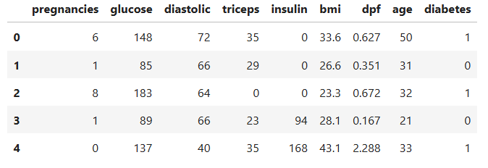

Output:

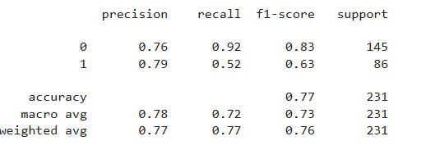

02.Cancer Prediction:

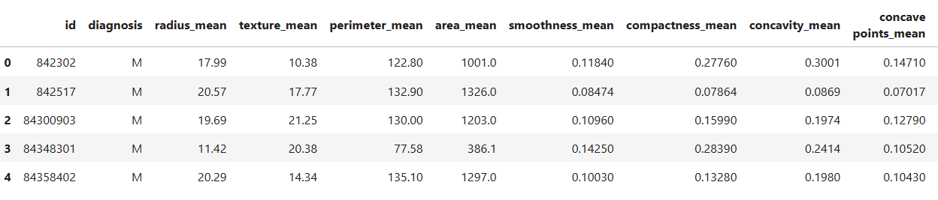

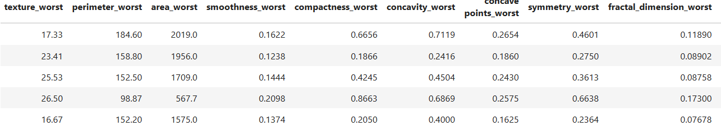

Output:

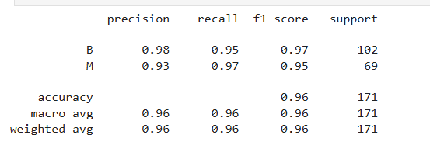

03.Chance of Admission for Higher Studies:

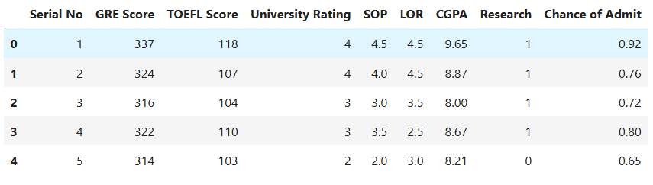

Output:

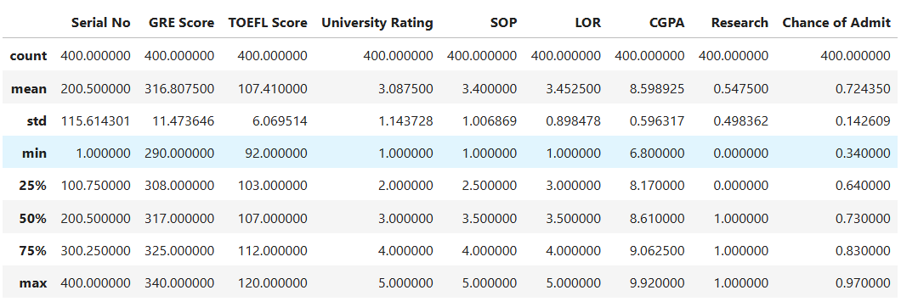

04.Credit Card Default Prediction:

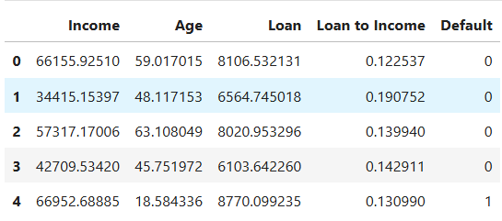

Output:

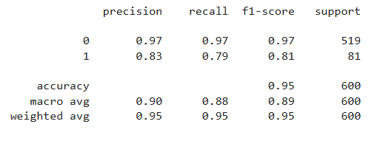

05.Directly Read Google Drive File:

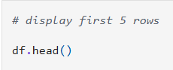

Output:

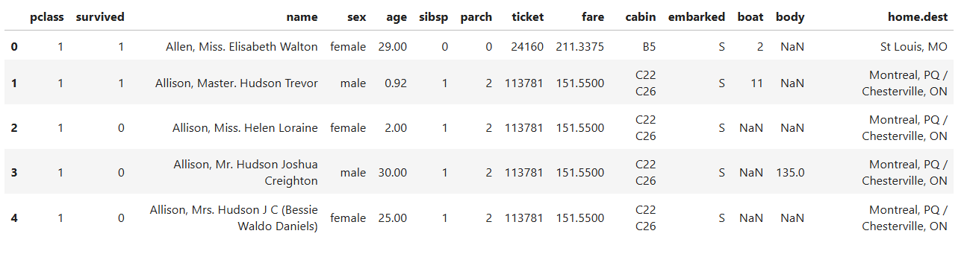

06.Explore DataFrame:

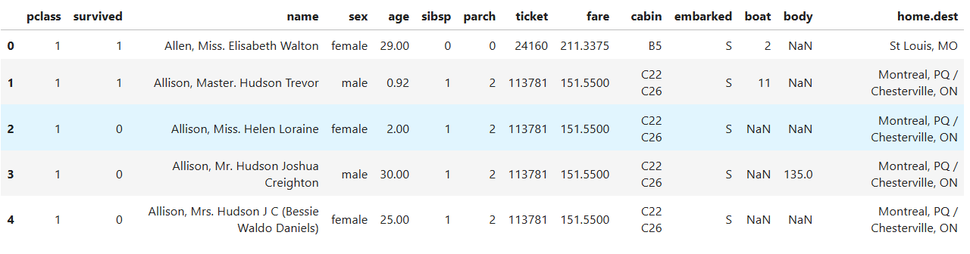

Output:

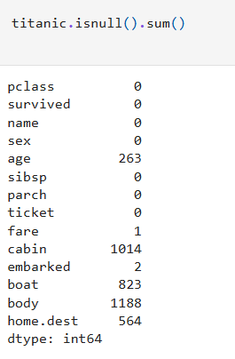

07.Fish Weight Prediction:

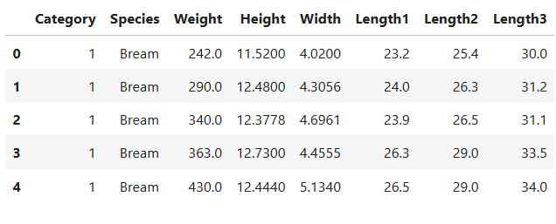

Output:

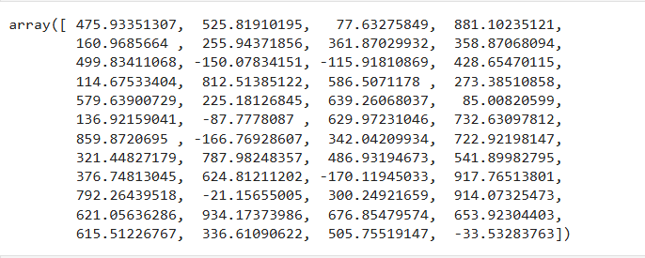

08.Galton's Height Data Linear Regression:

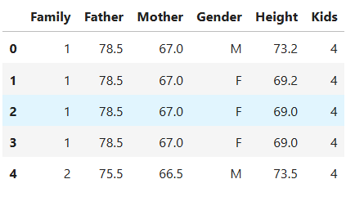

Output: 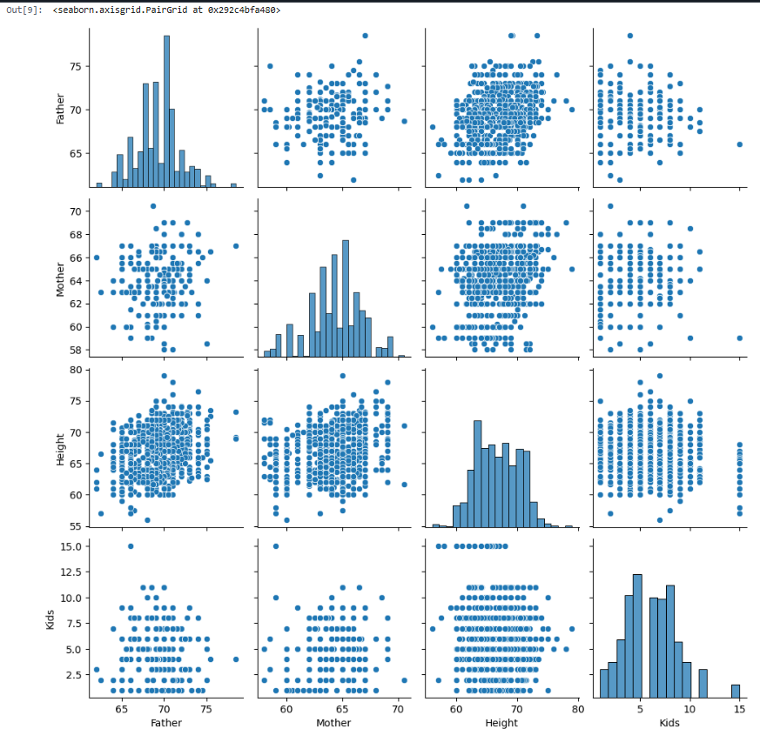10.Multi Category Classification:

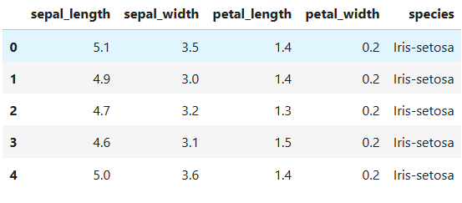

Output:

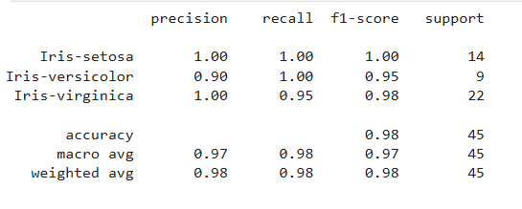

7.CONCLUSION

The internship conducted under YBI Foundation provided comprehensive knowledge and practical experience in the field of Machine Learning and Data Science. Throughout the internship, multiple projects were successfully implemented, covering important concepts such as data preprocessing, data analysis, model building, and performance evaluation.

All the projects, including Binary Classification, Cancer Prediction, Admission Prediction, Credit Card Default Prediction, DataFrame Exploration, Fish Weight Prediction, Height Data Analysis, Ice Cream Revenue Prediction, and Multi-class Classification, helped in understanding different types of machine learning problems such as classification and regression. These projects demonstrated how machine learning models can be applied to real-world datasets from domains like healthcare, finance, education, and business.

The implementation of these projects using Python programming and libraries such as Pandas, NumPy, Matplotlib, Seaborn, and Scikit-learn provided hands-on experience in writing efficient code and building predictive models. Each project followed a structured approach, including data loading, preprocessing, splitting into training and testing datasets, model training, prediction, and evaluation using appropriate metrics.

The coding part of the internship played a crucial role in strengthening programming skills and understanding the practical aspects of machine learning. Writing and executing code in platforms like Google Colab helped in developing the ability to handle datasets, debug errors, and optimize model performance.

Moreover, the internship enhanced analytical thinking and problem-solving skills by enabling the conversion of real-world problems into machine learning solutions. It also provided a clear understanding of evaluation metrics such as accuracy, precision, recall, mean squared error, and R² score, which are essential for measuring model performance.

Overall, this internship was highly beneficial in building a strong foundation in Machine Learning. It improved both theoretical knowledge and practical skills, preparing for future opportunities in Data Science and Artificial Intelligence, and enabling the development of real-world intelligent systems.

8.REFRENCES

WEBLINKS:

YBI Foundation – Internship training materials and datasets

Google Colab – For code execution and model development

Python Official Documentation – https://docs.python.org/3/

Pandas Documentation – https://pandas.pydata.org/docs/

NumPy Documentation – https://numpy.org/doc/

Matplotlib Documentation – https://matplotlib.org/stable/contents.html

Seaborn Documentation – https://seaborn.pydata.org/

Scikit-learn Documentation – https://scikit-learn.org/stable/

Jupyter Notebook – https://jupyter.org/

Google Drive – For dataset storage and sharing

